DASHBOARDS TUTORIAL

1. Non – Map Sheet (Statewise Profit)

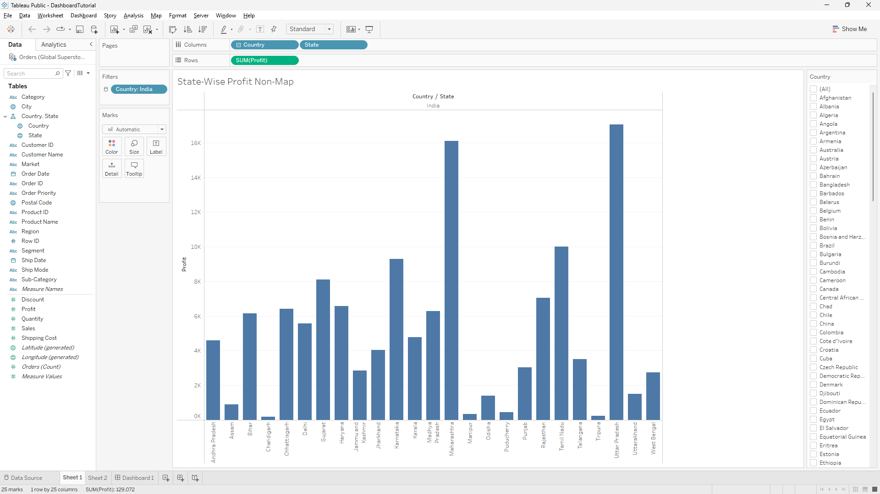

1. Maps – State Profits

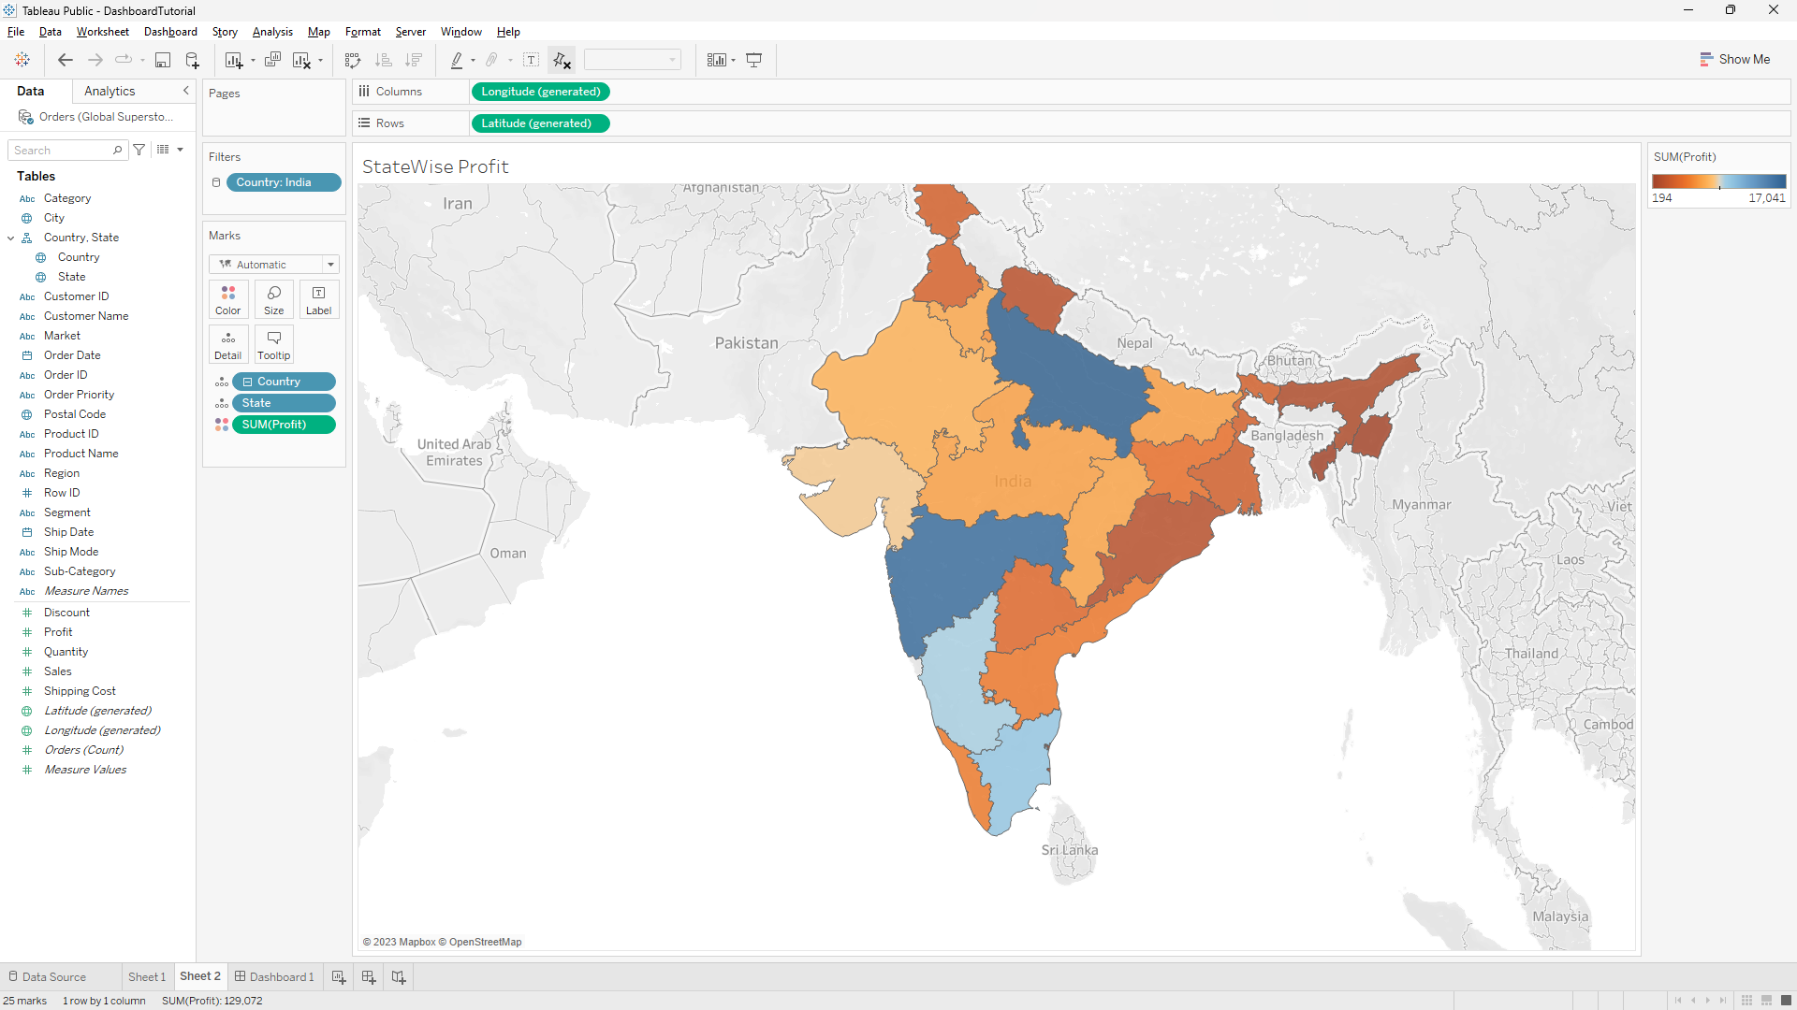

1. Integrating into Dashboard and Creating Web Links with On - Select Feature

